BANK LOAN REPORT QUERY DOCUMENT

A. BANK LOAN REPORT | SUMMARY
KPI’s:
Total Loan Applications
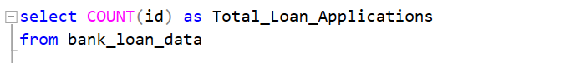
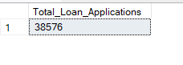
Total CMTD Loan Applications
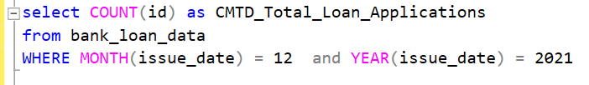
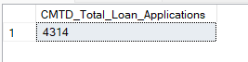
Total PMTD Loan Applications
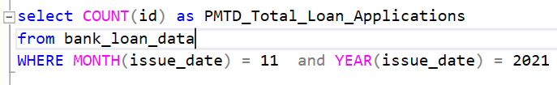
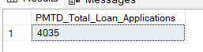
Total Funded Amount
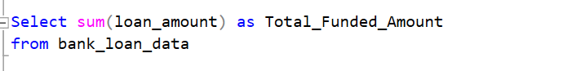
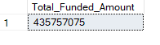
Total CMTD Funded Amount
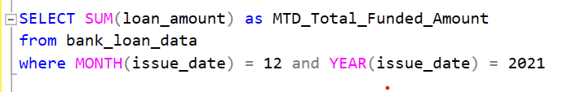
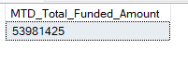

Total PMTD Funded Amount
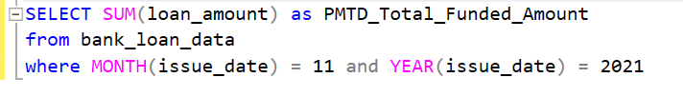
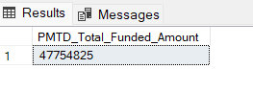

Total Amount Received
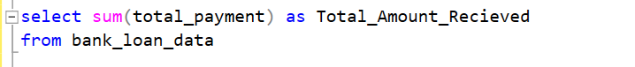
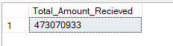

Total MTD Amount Received
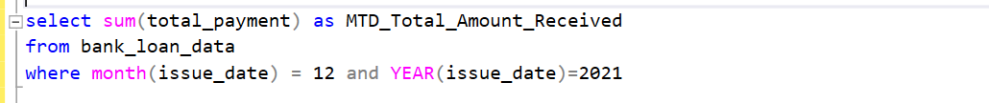
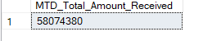

Total CMTD Amount Received
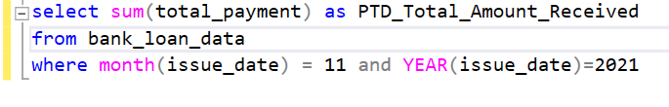
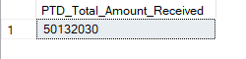

Total Average Total Interest Rate
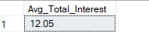
Total Average MTD Interest Rate
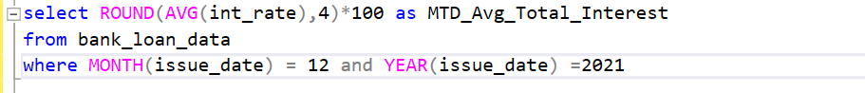
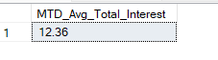
Total Average PMTD Interest Rate
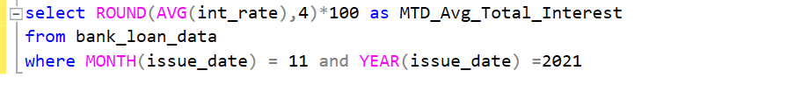
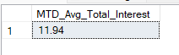

Total Average Total DTI

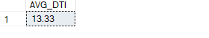

Total Average MTD DTI
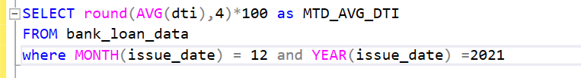
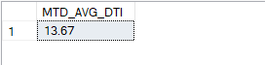

Total Average PMTD DTI
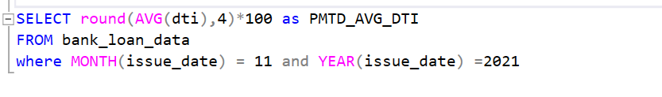
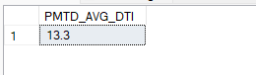
Good Loan Issued
Total Good Loan Percentage
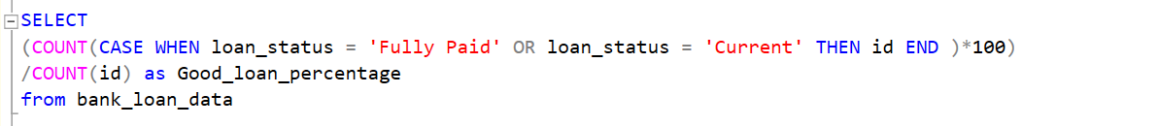
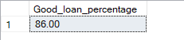

Total Good Loan Applications
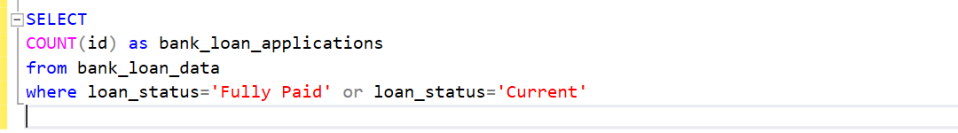
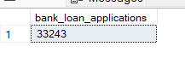

Total Good Loan Funded Amount
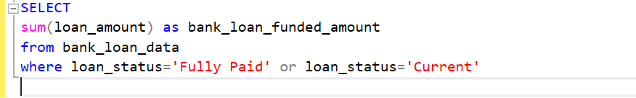
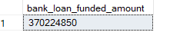

Total Good Loan Received Amount
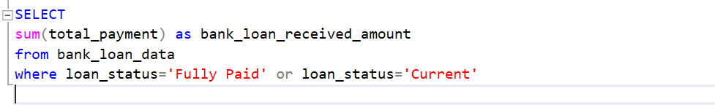
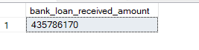

Bad Loan Issued
Total Bad Loan Percentage
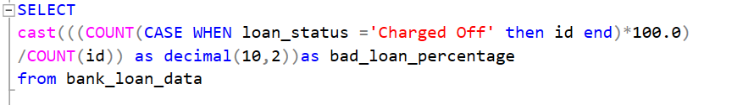
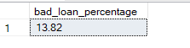
Total Bad Loan Applications
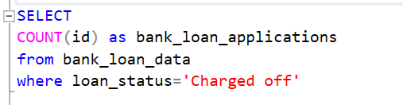
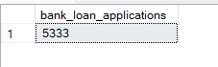
Total Bad Loan Funded Amount
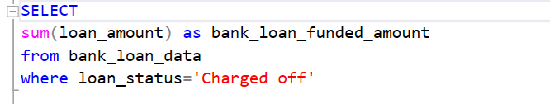
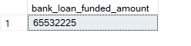
Total Good Loan Received Amount
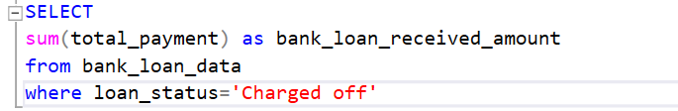
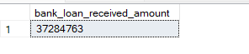
Loan Status
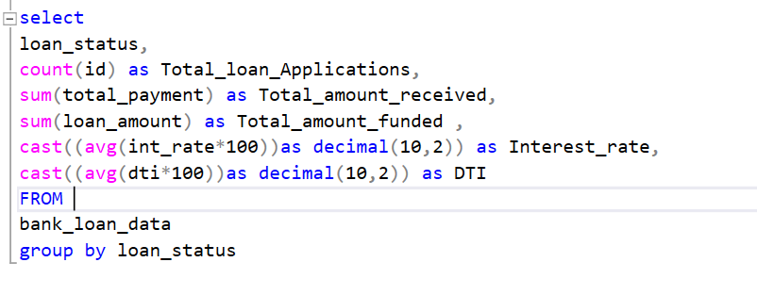

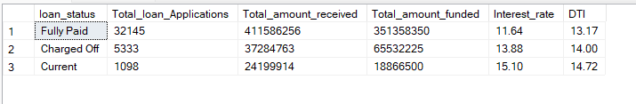

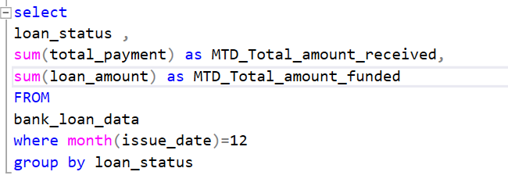

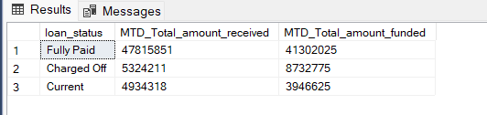

Monthly Trend
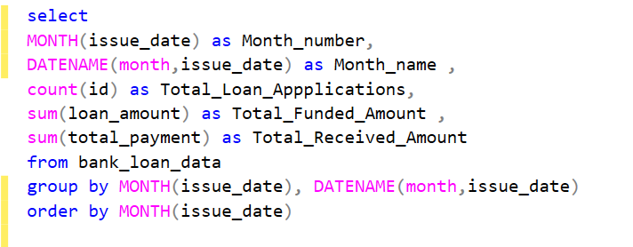
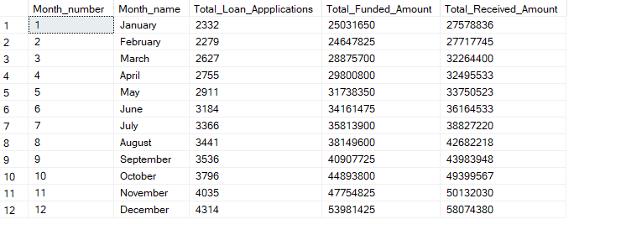
Regional Analysis by state
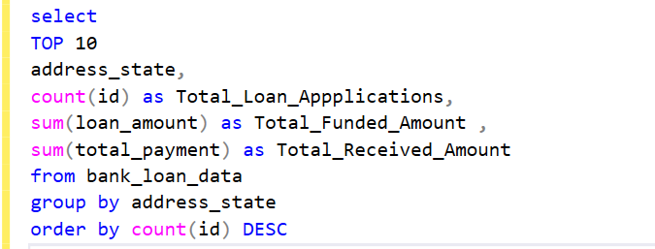

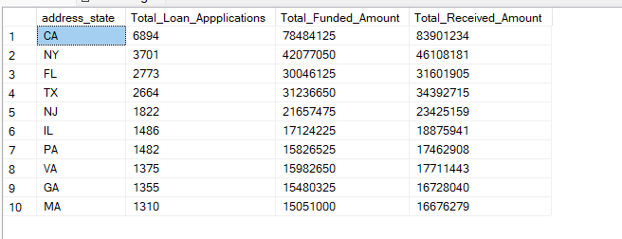
Loan Term Analysis
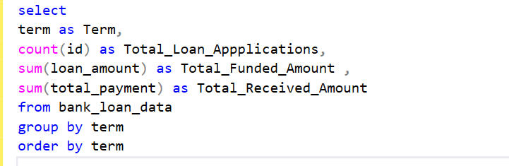
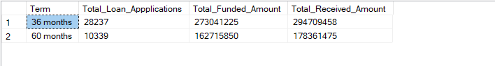
EMP LENGTH ANALYSIS

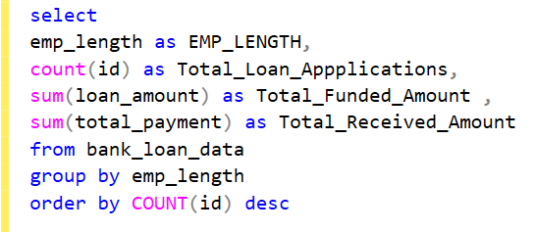
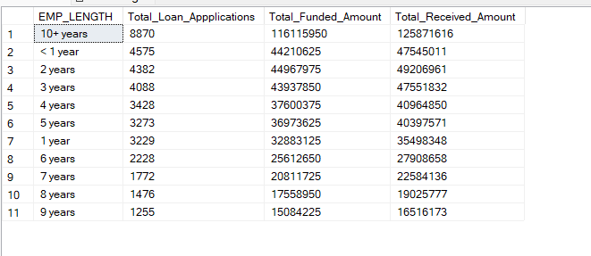
Loan Purpose Breakdown
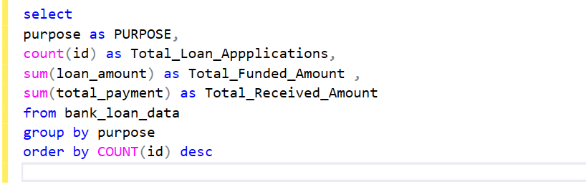

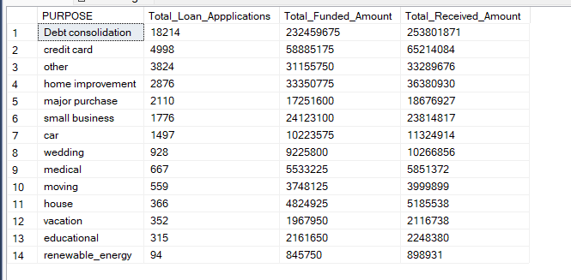

Home Ownership Analysis
